Rare Loop Function:
A function which is never negative, it is the combination of a straight line in 1st quadrant and the horizontal constant line y=0, for all negative values of the straight line.

Neuron:
Transforms the input into output.

Weights:
During training, the network adjusts these weights to learn the relationships between inputs and outputs. Higher weights mean stronger influence of one neuron on another.

Biases:
Biases are added to the weighted sum of inputs within a neuron. They allow a neuron to activate even if all its inputs are zero.
Think of bias as a threshold that a neuron needs to overcome to "fire".

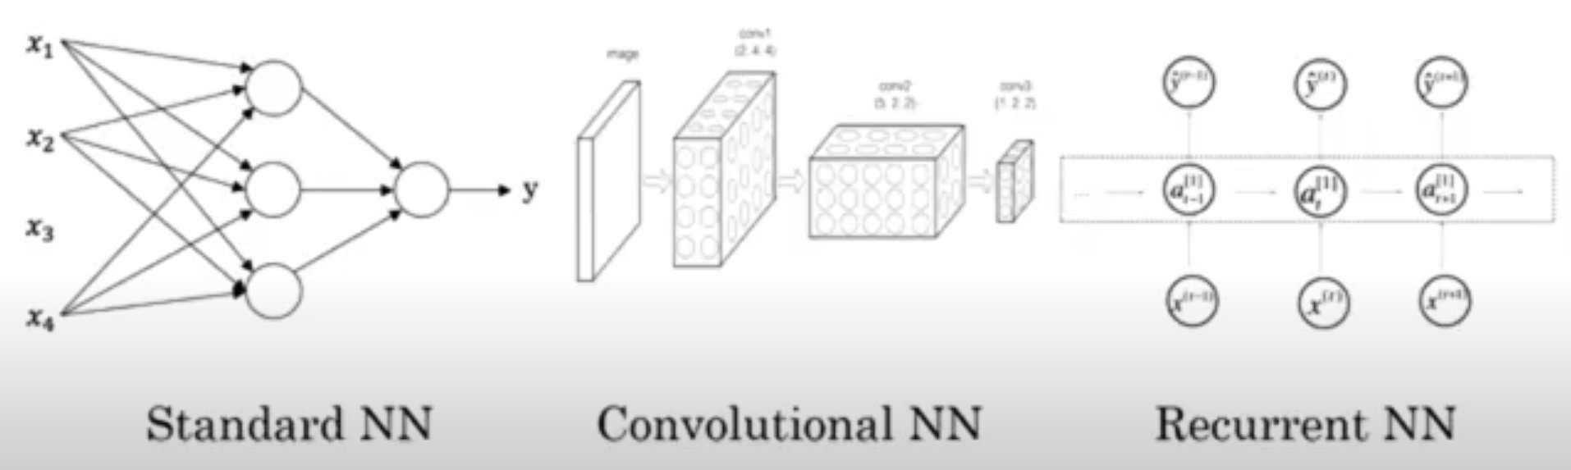

Supervised learning:
It essentially involves training a model on a set of input data that is paired with the correct output, allowing the algorithm to learn the relationship between the two.

Audio: RNN

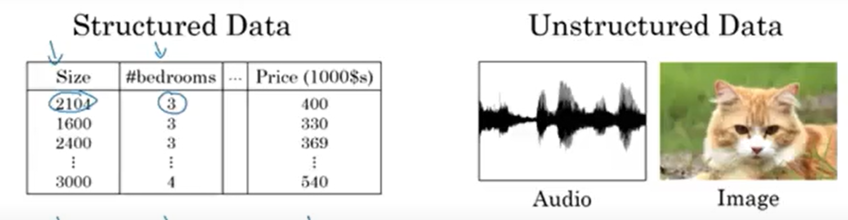

Why sigmoid has been replaced with rectified linear unit (relu)?
Sigmoid functions has gradient almost zero at some places = learning almost zero.
Gradient descent works better on Relu.

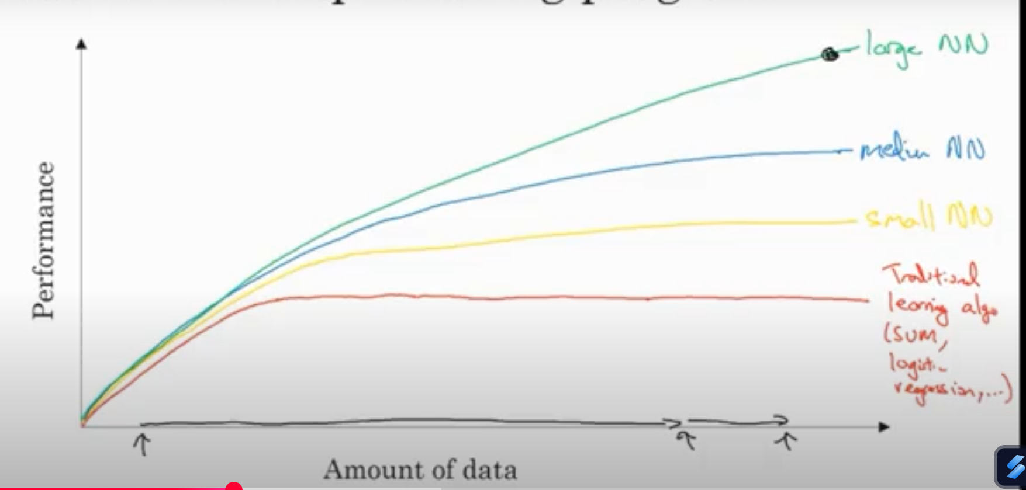

More data, bigger NN, more computation power.

Computational Process of NN:
Forward pass OR Forward propagation
Backward pass OR Back propagation

Binary Classification :
X feature vector = extracts features from input in form of a matrix.
Converts X feature vector into a binary output Y (0/1)

Logistic Regression :
Used in Supervised learning for binary classification problems.
Dim of w is the same as the input.
Dim of b is the same as the output.
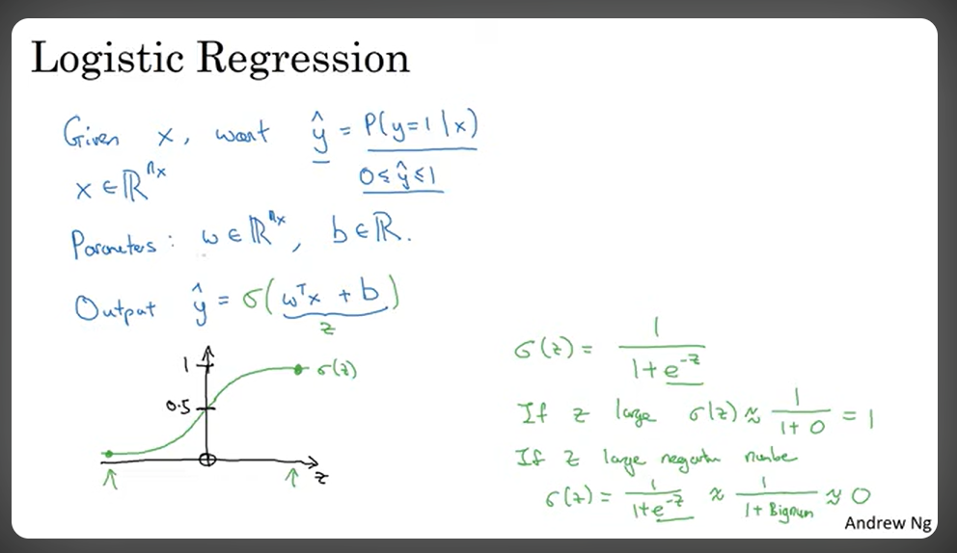

Loss Function : L
Used to find how good the output given by our model is compared to the expected output, calculated by Logistic Regression.
Applied on a single output pair.
Most common choice :MSE= (y model - y expected) ^2 ×0.5
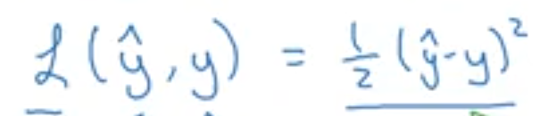
But MSE does not deal with gradient descent properly.

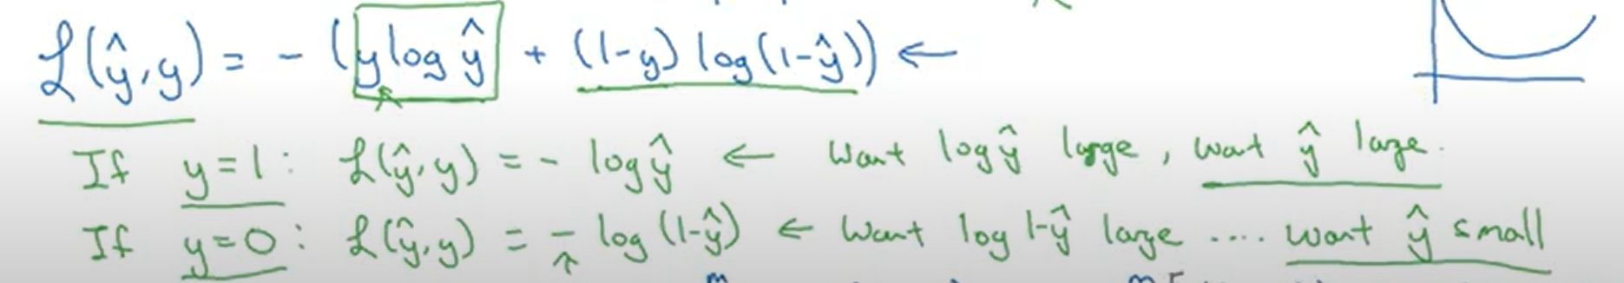
Above loss function is a convex function, local minima-the lowest loss or deviation from expected output for some w and b.

Cost Function : J
How well training is being done on the entire set.
Applied on entire set.

